**Game Walkthrough**

Game Objective  
  
The game objective is to discover a code which has been randomly created by the computer.  
To crack the code, user makes guesses and the computer responds with clues.  
User gets maximum 10 guesses.   
  
Once the game started, user is prompted with MainMenu as shown in the figure below.

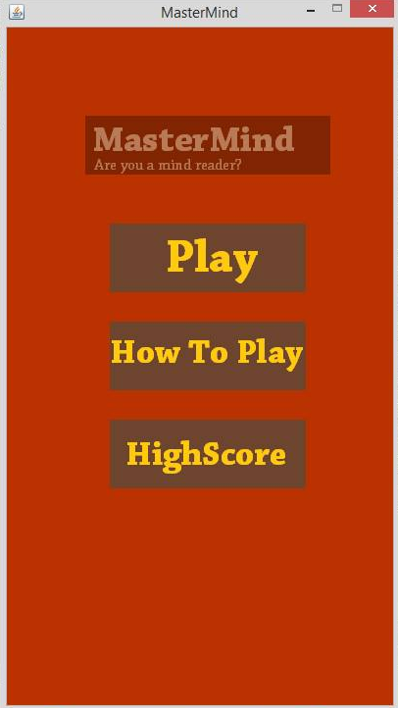

On the Main Menu, there are three buttons to choose:

1. Play button
2. How to Play button
3. HighScore button.
4. Play button

Clicking the Play button, the MasterMind game window would be appeared. The objective of Mastermind is to guess a *secret code* that the program has chosen.  The computer randomly picks four colors from a pallet of ten. In this version of Mastermind, the player is allowed to choose only four 4 of 8 colors by clicking on the round button. The pop up window will be appeared to ask player to enter the chosen color code for that particular round button by typing the full name or the first letter (e.g. ‘green’ or ‘g’) of the color on the text field. There are several colors for player to choose from the right column: green, yellow, blue, white, red, pink, cyan or orange. Note that duplicate colors are allowed in the color code. After filled in all four color code, player can check their guessed color by pressing ‘Check’ button or else, the pop up window will be appeared to tell player to enter their guessed colors.

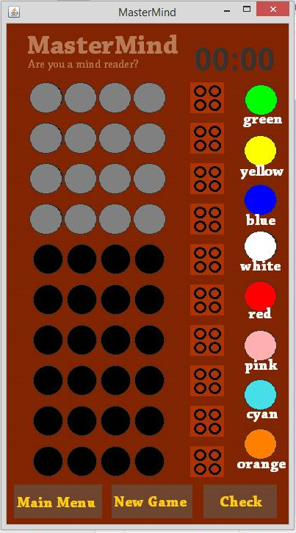

The ‘Check’ button will compare player’s guessed colors with computer’s randomly picked colors.

If the guess is correct, the overall score is displayed.  Otherwise, two hints are given as feedback: the number of correct choices in the guess –‘black’ color appears on pegs, the number of choices that are a correct color, but are not in the proper position in the sequence –‘white’ color appears on pegs. If the guess is not the same as the color code the game generated previously, user needs to fill with their next guesses on the next row of empty color code. Note that the timer on the top right hand panel indicates the time taken by a player to make a correct guessed, which will keep running until the correct guess is guessed or the number of guesses reaches 10. The total time taken and no of rows may affect your score.

1. How To Play button

Clicking the How to Play button would open up the How To Play page as in the figure blow which provides some info on how to play the game. Some brief explanation on the game objective, how to make a guess and button clues function are displayed.

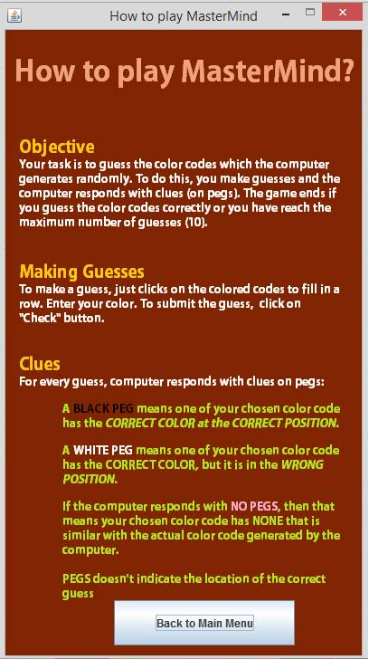

1. High Score button

Clicking the HighScore button would open up the HighScore page. The highest scored and the user’s name are displayed on this page.

